LINK STATE ROUTING

#include<stdio.h>
int cost[10][10];
int dist[10];
int arr[20];
void dijkstra(int);
int search(int);
int length_of( int * );
void print_route(int, int);
int prev[20];
int order_arr[20];
int src;
main()
{
int num_nodes,i, j, d;
printf("Enter number of nodes:");
scanf("%d", &num_nodes);
printf("Enter the source node:");
scanf("%d", &src);
printf("Enter the cost matrix, For infinity enter 999\n");
for(i=0; i <num_nodes; i++)
for(j=0; j <num_nodes; j++)
scanf("%d", &cost[i][j]);

djikstra( num_nodes);
}
void djikstra(int _num_nodes )
{
int i, min_val, l;
int k =0;
int m =0;
int min =999;
int last;
int neighbour[20];
for(i = 0; i <20; i++)
{
arr[i] = -1;
neighbour[i] = -1;
order_arr[i] = -1;
prev[i] = -1;
}
arr[0] = src;
last =0;
for(i = 0; i <_num_nodes; i++)
{
if(i != src)
{
if( cost[src][i] < 999)
{
dist[i] = cost[src][i];
prev[i] = src;
}
else
dist[i] = 999;

}
else
{
dist[i] = 0;
}
}
do {
for(i=0; i < _num_nodes; i++)
{
if(search(i) == 0)
{
if(dist[i] < min)
{
min = dist[i];
min_val = i;
}
}
}
last++;
arr[last] = min_val;
for(i=0; i<_num_nodes; i++)
{
if(search(i) == 0)
{
if(cost[min_val][i] < 999)
{
neighbour[m] = i;
m++;
}
}
}
m =0;
while(neighbour[m] != -1)
{
if(dist[min_val] +
cost[min_val][neighbour[m]]<
dist[neighbour[m]])
{
dist[neighbour[m]] =
dist[min_val] + cost[min_val][neighbour[m]];
prev[neighbour[m]] = min_val;
}
m++;
}
m=0;
for(i = 0; i <_num_nodes; i++)
neighbour[i] = -1;
min =999;
min_val = -1;
}while( length_of(arr) != _num_nodes);
i =1;
l=1;
while( i < _num_nodes)
{
print_route(i, l);
printf("[ distance = %d]", dist[i]);
printf("\n");
i++;
l++;
for(k = 0; k <20; k++)
order_arr[k] = -1;

}
}
void print_route( int _i, int _l)
{
int begin;
int * ptr;
int h, len, temp;
static int inc[20];
if( _i == src)
{
ptr = order_arr;
while(*ptr != -1)
ptr++;
len = ptr-order_arr;
for(h =0; h < len/2; h++)
{
temp = order_arr[h];
order_arr[h] = order_arr[len - h -1];
order_arr[len-h-1] = temp;
}
ptr = order_arr;
printf("%d", src);
while(*ptr != -1)
{
printf("->%d ", *ptr);
ptr++;

}
return;
}
else
{
order_arr[inc[_l]] = _i;
inc[_l]++;
print_route(prev[_i], _l);
}
}
int search(_i)
{
int i =0;
while (arr[i] != -1)
{
if(_i == arr[i])
break;
else
i++;
}
if(arr[i] == -1)
return 0;
else
return 1;

}
int length_of( int _arr[])
{
int i=0;
while(_arr[i] != -1)
i++;
return i;
}

OUTPUT
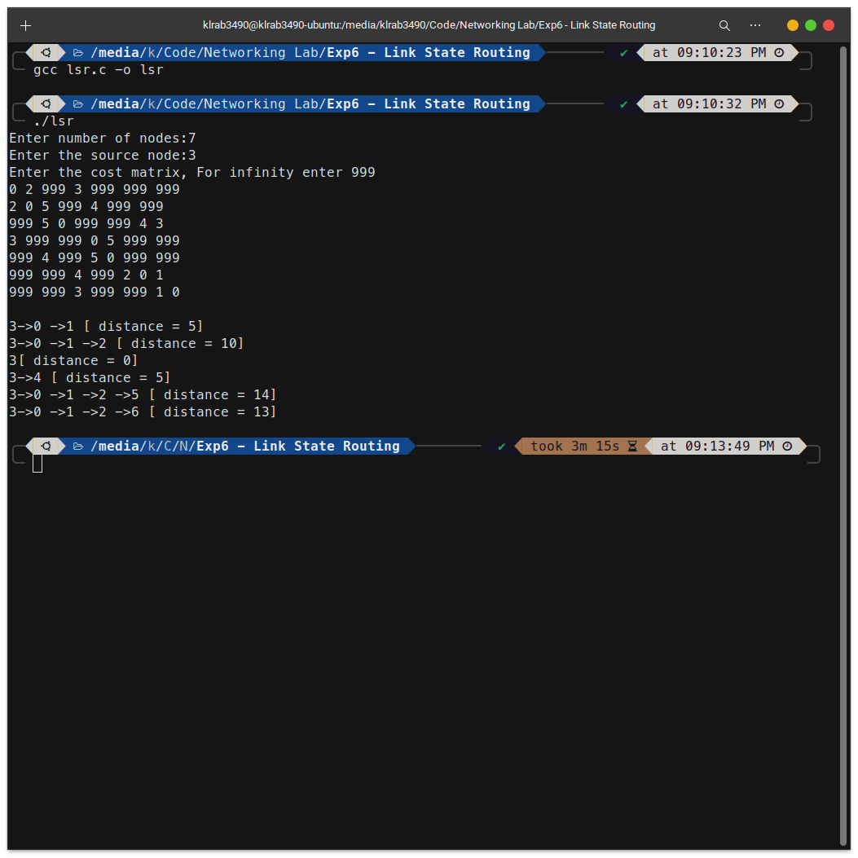

OUTPUT
1.BEFORE FILE TRANSFER
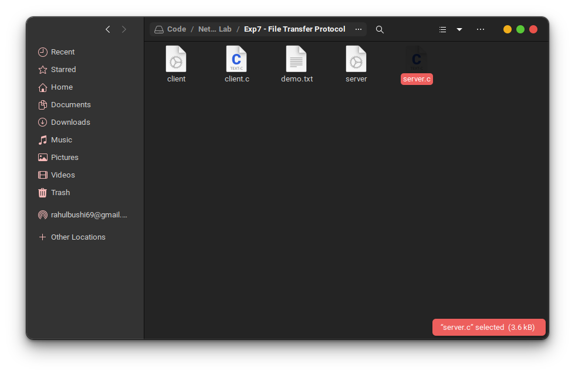
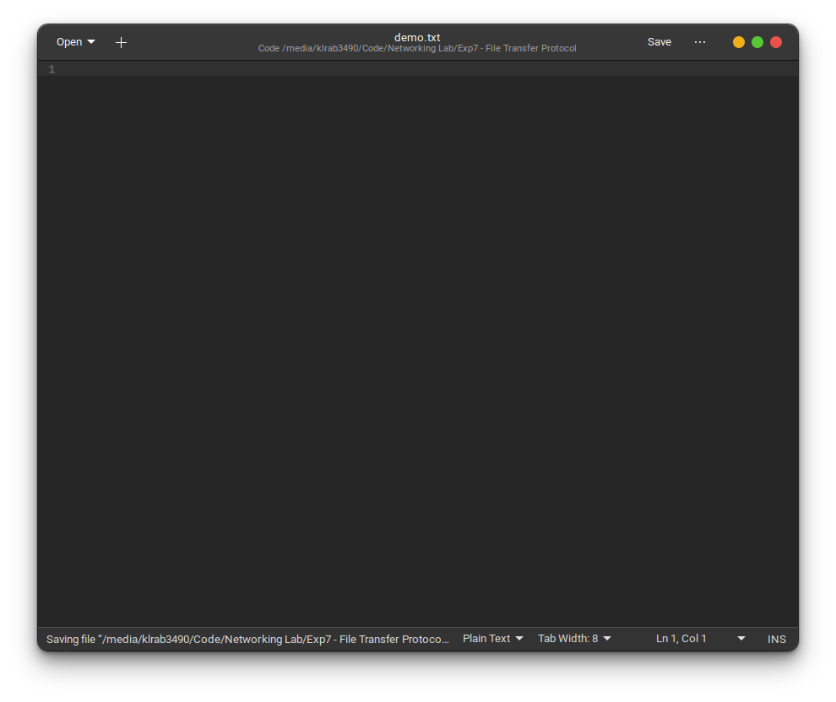

2.AFTER FILE TRANSFER


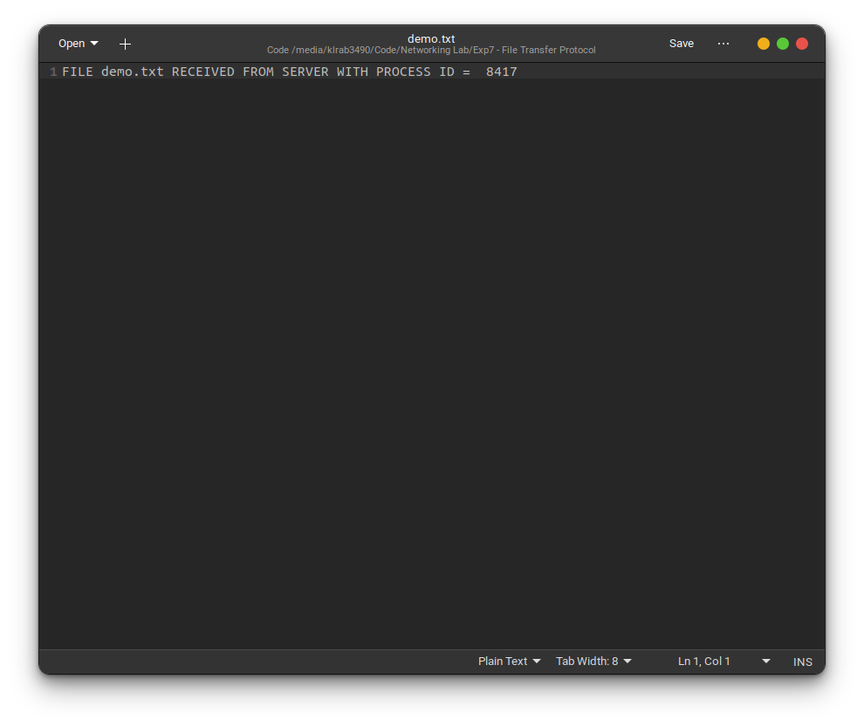
FILE TRANSFER PROTOCOL

CLIENT

#include<stdio.h>
#include<string.h>
#include<sys/socket.h>
#include<sys/types.h>
#include<netinet/in.h>
#include<arpa/inet.h>
#include<fcntl.h>
#include<stdlib.h>
#include<unistd.h>

int main(int argc, char * argv[]) {
int n, fd, i;
int sock_ctrl, sock_data;
char buffer[100], line[100], cmd[100];
char name[100];
char * p;
struct sockaddr_in servaddr;
if (argc != 3) {
fprintf(stderr, "Usage: ./client
IPaddress_of_server port\n");
exit(1);
}
if ((sock_ctrl = socket(AF_INET,
SOCK_STREAM, 0)) < 0) {
printf("Cannot create control socket\n");
exit(1);
}
bzero((char * ) & servaddr, sizeof(servaddr));
bzero(line, sizeof(line));
bzero(buffer, sizeof(buffer));
servaddr.sin_family = AF_INET;
servaddr.sin_port = htons(atoi(argv[2]));
inet_pton(AF_INET, argv[1], & servaddr.sin_addr);
if (connect(sock_ctrl, (struct sockaddr * )
& servaddr, sizeof(servaddr)) < 0) {
perror("Connection failed, control
socket:");
exit(1);
}
printf(" Enter \"get\" for receiving file from server\n");
printf(" Enter \"close\" for closing
connection\n");
while (1) {
i = 0;
if ((sock_data = socket(AF_INET,
SOCK_STREAM, 0)) < 0) {
perror("Creation of client data socket failed");
exit(1);
}
printf("Enter command:");
scanf("%s", cmd);
n = write(sock_ctrl, cmd, sizeof(cmd));
if (strcmp(cmd, "close") == 0) {
close(sock_data);
close(sock_ctrl);
break;
}
printf("Enter filename:");
scanf("%s", name);
printf("name of file = %s\n", name);
if ((fd = open(name,
O_WRONLY | O_CREAT)) < 0) {
perror("Error in opening file ");
exit(1);
}
write(sock_ctrl, name, sizeof(name));
servaddr.sin_port = htons(atoi(argv[2])
+ 1);
n = connect(sock_data, (struct sockaddr
* ) &servaddr, sizeof(servaddr));
while (n == -1) {
n= connect(sock_data,(struct
sockaddr * ) &servaddr, sizeof(servaddr));
perror("cannot connect");
}
do {
n=read(sock_data,buffer,
sizeof(buffer));
write(fd, buffer, n);
i += n;
} while (n > 0);
if (buffer[0] == '@') {
p = buffer;
printf("%s\n", p++);
remove(name);
}
}
return 0;
}

SERVER
#include<stdio.h>
#include<string.h>
#include<sys/socket.h>
#include<sys/types.h>
#include<netinet/in.h>
#include<arpa/inet.h>
#include<fcntl.h>
#include<stdlib.h>
#include<unistd.h>

int main(int argc, char * argv[]) {
int n, m, fd, i;
int sock_ctrl,sock_data,listen_control,
listen_data;
int file_present = 1;
char name[100], buffer[100], cmd[100];
struct sockaddr_in servaddr, cliaddr;
int cli_len = sizeof(cliaddr);
if (argc != 2) {
fprintf(stderr, "Usage: ./server port\n");
exit(1);
}
if ((listen_control = socket(AF_INET, SOCK_STREAM, 0)) < 0) {
perror("cannot create listening socket for control connection");
exit(1);
}
bzero( & servaddr, sizeof(servaddr));
servaddr.sin_family = AF_INET;
servaddr.sin_addr.s_addr =
htonl(INADDR_ANY);
servaddr.sin_port = htons(atoi(argv[1]));
if (bind(listen_control, (struct sockaddr * ) & servaddr, sizeof(servaddr)) < 0) {
perror("server bind failed for control listening socket");
exit(1);
}
listen(listen_control, 5);
if ((listen_data = socket(AF_INET, SOCK_STREAM, 0)) < 0) {
perror("cannot create listening socket for data connection");
exit(1);
}
servaddr.sin_port = htons(atoi(argv[1]) + 1);
if (bind(listen_data, (struct sockaddr * ) & servaddr, sizeof(servaddr)) < 0) {

perror("server bind failed for data listening socket");
exit(1);
}
listen(listen_control, 5);
listen(listen_data, 5);
for (;;) {
if ((sock_ctrl = accept(listen_control,
(struct sockaddr * ) & servaddr, & cli_len)) < 0) {
perror("accept failed");
exit(1);
}
servaddr.sin_port = htons(atoi(argv[1] +1));
if (fork() == 0) {
close(listen_control);
while (1) {
i = 0;
n = read(sock_ctrl, cmd, 100);
if (strcmp(cmd, "close") == 0) {
break;
} else {
read(sock_ctrl, name, 100);
if ((fd = open(name, O_RDONLY)) < 0) {
sprintf(buffer, "@FILE NOT
FOUND PROCESS ID = %d",getpid());
perror("error in opening file");
file_present = 0;
}
if ((sock_data = accept(listen_data,
(struct sockaddr * ) & servaddr, &
cli_len)) < 0) {
perror("accept failed");
exit(1);
}
if (file_present == 1) {
do {

n = read(fd, buffer, sizeof(buffer));
write(sock_data, buffer, n);
i = i + n;
} while (n > 0);
close(fd);
sprintf(buffer, "FILE %s RECEIVED
FROM SERVER WITH PROCESS ID = % d ",name, getpid());

m = write(sock_data, buffer, strlen(buffer));
}
else {
m = write(sock_data, buffer, sizeof(buffer));
file_present = 1;
bzero(buffer, sizeof(buffer));
}
close(sock_data);
}
}
close(sock_ctrl);
close(listen_data);
exit(0);
}
close(sock_ctrl);
}
close(listen_control);
close(listen_data);
}

CLIENT
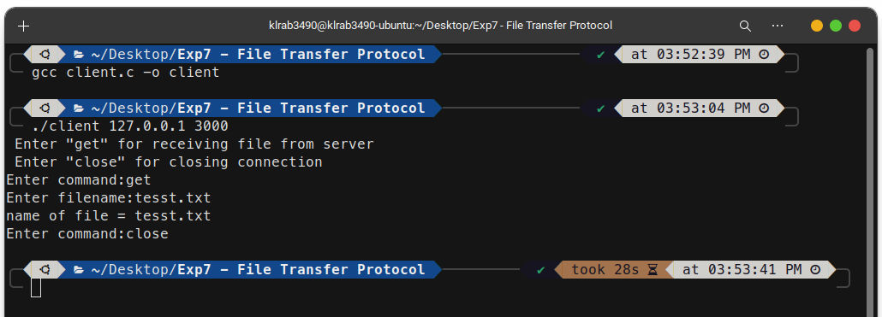

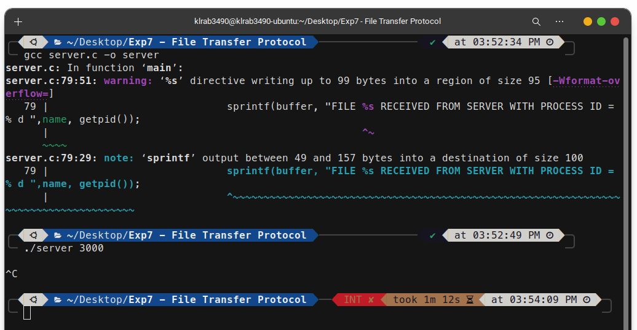
SERVER

LEAKY BUCKET ALGORITHM

#include <stdio.h>
#include <stdlib.h>
#include <unistd.h>
#define NOF_PACKETS 10
int my_rand(int a) {
int rn = (random() % 10) % a;
return rn == 0 ? 1 : rn;
}
int main() {
int packet_sz[NOF_PACKETS], i, clk, b_size, o_rate, p_sz_rm=0, p_sz, p_time, op;
for(i = 0; i < NOF_PACKETS; ++i)
packet_sz[i] = my_rand(6) * 10;
for(i = 0; i < NOF_PACKETS; ++i)
printf("\npacket[%d]:%d bytes\t", i, packet_sz[i]);
printf("\nEnter the Output rate:");
scanf("%d", &o_rate);
printf("Enter the Bucket Size:");
scanf("%d", &b_size);
for(i = 0; i < NOF_PACKETS; ++i) {
if( (packet_sz[i] + p_sz_rm) > b_size)
if(packet_sz[i] > b_size)
printf("\n\nIncoming packet size (%d bytes) is Greater than bucket capacity (%d bytes) -
PACKET REJECTED", packet_sz[i], b_size);
else { printf("\n\nBucket capacity exceeded - PACKETS REJECTED!!"); }
else {
p_sz_rm += packet_sz[i];
printf("\n\nIncoming Packet size: %d", packet_sz[i]);
printf("\nBytes remaining to Transmit: %d", p_sz_rm);
p_time = my_rand(4) * 10;
printf("\nTime left for transmission: %d units", p_time);
for(clk = 10; clk <= p_time; clk += 10) {
sleep(1);
if(p_sz_rm) {
if(p_sz_rm <= o_rate)
op = p_sz_rm, p_sz_rm = 0;
else
op = o_rate, p_sz_rm -= o_rate;
printf("\nPacket of size %d Transmitted", op);
printf("----Bytes Remaining to Transmit: %d", p_sz_rm);
} else {
printf("\nTime left for transmission: %d units", p_time - clk);
printf("\nNo packets to transmit!!");
}
}
}
}
return 0;
}
OUTPUT
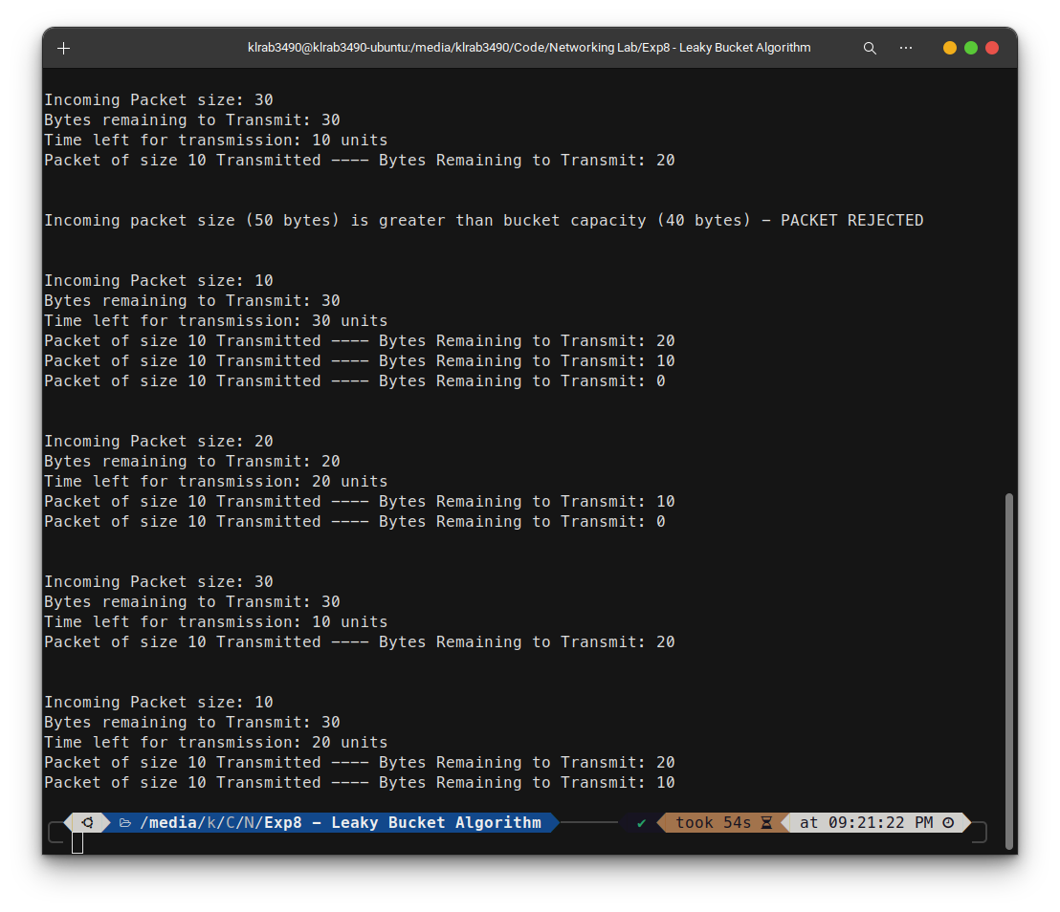
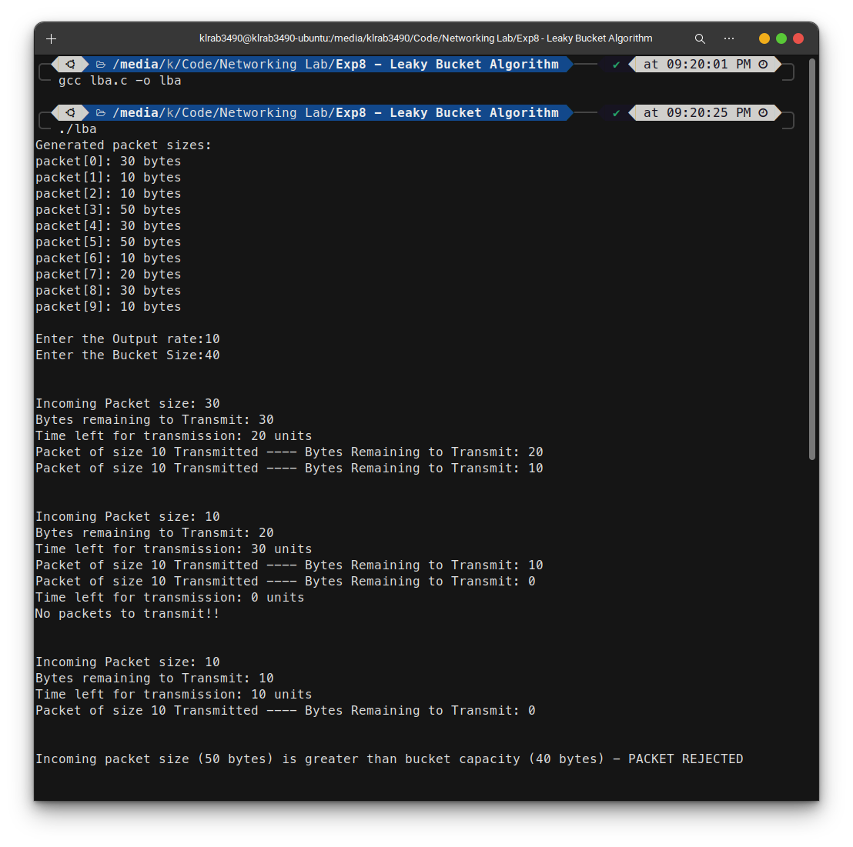

NS2

set ns [new Simulator]
# Define color for data flows
$ns color 1 Blue
$ns color 2 Red
# Open trace files
set tracefile1 [open out.tr w]
set winfile [open winfile w]
$ns trace-all $tracefile1
# Open nam file
set namfile [open out.nam w]
$ns namtrace-all $namfile
# Define the finish procedure
proc finish {} {
global ns tracefile1 namfile
$ns flush-trace
close $tracefile1
close $namfile
exec nam out.nam &
exit 0
}
# Create six nodes
set n0 [$ns node]
set n1 [$ns node]
set n2 [$ns node]
set n3 [$ns node]
set n4 [$ns node]
set n5 [$ns node]
$n1 color Red
$n1 shape box
# Create links between the nodes
$ns duplex-link $n0 $n2 2Mb 10ms DropTail
$ns duplex-link $n1 $n2 2Mb 10ms DropTail
$ns simplex-link $n2 $n3 0.3Mb 100ms DropTail
$ns simplex-link $n3 $n2 0.3Mb 100ms DropTail
set lan [$ns newLan "$n3 $n4 $n5" 0.5Mb 40ms LL Queue/DropTail MAC/Csma/Cd Channel]
# Give node position
$ns duplex-link-op $n0 $n2 orient right-down
$ns duplex-link-op $n1 $n2 orient right-up
$ns simplex-link-op $n2 $n3 orient right
$ns simplex-link-op $n3 $n2 orient left
# Set queue size of link(n2-n3) to 20
$ns queue-limit $n2 $n3 20
# Setup TCP connection
set tcp [new Agent/TCP/Newreno]
$ns attach-agent $n0 $tcp
set sink [new Agent/TCPSink/DelAck]
$ns attach-agent $n4 $sink
$ns connect $tcp $sink
$tcp set fid_ 1
$tcp set packet_size_ 552
# Set up FTP over TCP connection
set ftp [new Application/FTP]
$ftp attach-agent $tcp
# Setup a UDP connection
set udp [new Agent/UDP]
$ns attach-agent $n1 $udp
set null [new Agent/Null]
$ns attach-agent $n5 $null
$ns connect $udp $null
$udp set fid_ 2
# Setup a CBR over UDP connection
set cbr [new Application/Traffic/CBR]
$cbr attach-agent $udp
$cbr set type_ CBR
$cbr set packet_size_ 1000
$cbr set rate_ 0.01Mb
$cbr set random_ false
# Schedule the events
$ns at 0.1 "$cbr start"
$ns at 1.0 "$ftp start"
$ns at 124.0 "$ftp stop"
$ns at 125.5 "$cbr stop"
proc plotWindow {tcpSource file} {
global ns
set time 0.1
set now [$ns now]
set cwnd [$tcpSource set cwnd_]
puts $file "$now $cwnd"
$ns at [expr $now+$time] "plotWindow $tcpSource $file"
}
$ns at 0.1 "plotWindow $tcp $winfile"
$ns at 125.0 "finish"
$ns run

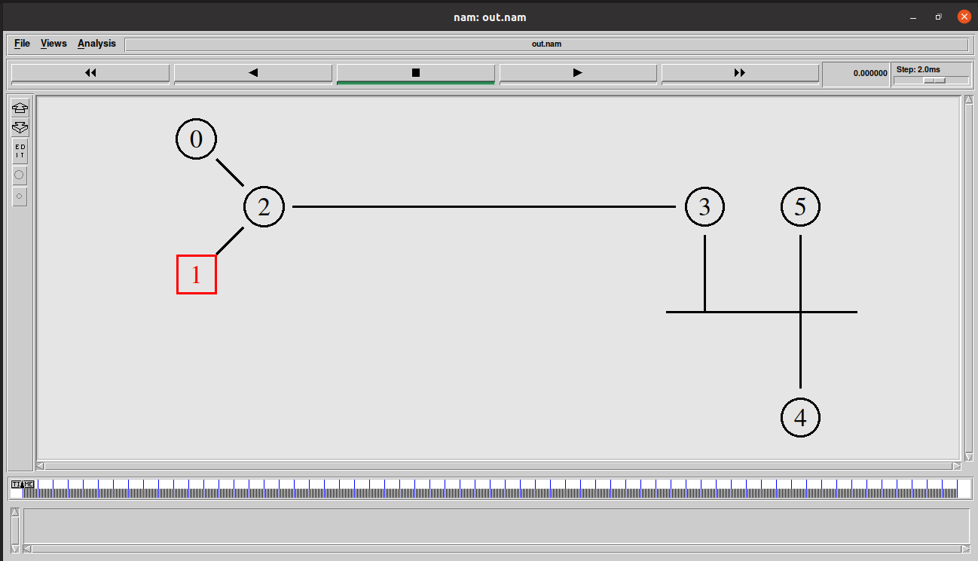
OUTPUT

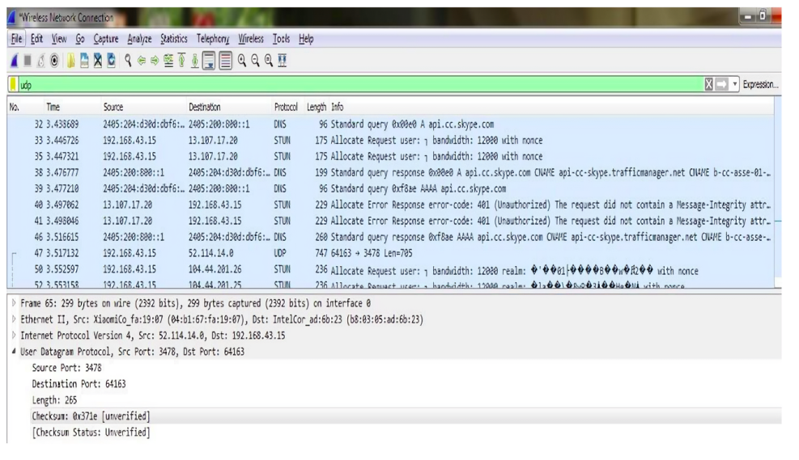
OUTPUT

